# **WORKGROUPS:**

**>spt_identity:**

Workgroup-🡪stored under identity object.

select * from identityiq.spt_identity where WORKGROUP=true

and name='Demo AD';

**>spt_identity_workgroup**:------only contains workgroups which have members inside it

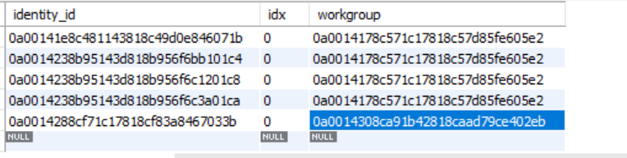

**WORKFLOWS:**

**>spt_workflow:**

Stores all the workflows that are created-🡪with complete info like

**Colums info**

Variable variables(xml part)

Step complete workflow with code

**>spt_workflow_case**

**Tracks the workflow execution**

Stores the instance of workflow that currently executing

Removes after the workflow execution completes

**>spt_task_result**

Stores the result

**>spt_rule**

If workflow calls any rule-🡪then a record will be inserted in this table

**>spt_work_item**

**CERTIFICATIONS:**

**>spt_certification**

--🡪stores individual access review for each reviewer (Active)

-🡪eg:access review for James **(Campaign:AD manager certification🡪entitlements**)

>each one will have unique id

**>spt_Certification_definition**🡪

Stores definitions and metadata for certification campaigns.

>Scope: =🡺: Defines the scope of the certification, such as specific applications, roles, or user populations.

stores Certification object after creating Certification-🡪contains total info like reviewers, rules defined, staging enabled, notifications etc.

**>spt_certification_group**--------🡪stores whole certification --🡪gives Certification definition id

**>spt_certification_entity**

The identities for whom we are certifying

SELECT * FROM identityiq.spt_certification_entity where certification_id="0a0014188fe2194b818fe21da2020022";(james certification id)

>> danalakshmi,ramudu,younus

**>spt_certification_item**

No of entitlements of entity===no of certification items

SELECT * FROM identityiq.spt_certification_item where certification_entity_id="0a0014188fe2194b818fe21da3c80025"; (danalakshmi)

>> CN=backup-🡪CERT_ITEM1

>>CN=Account-🡪 CERT_ITEM2

**FOREIGN KEY (`exception_entitlements`) REFERENCES `spt_entitlement_snapshot` (`id`)**

**>spt_certifiers--🡪stores the certifiers of campaign**

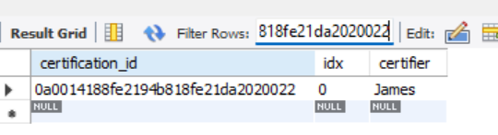

**>spt_certification_tags**

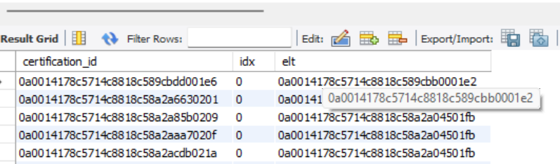

>elt=🡺foreignkey---references ‘id’ in spt_tags table

**>Spt_certification_action**

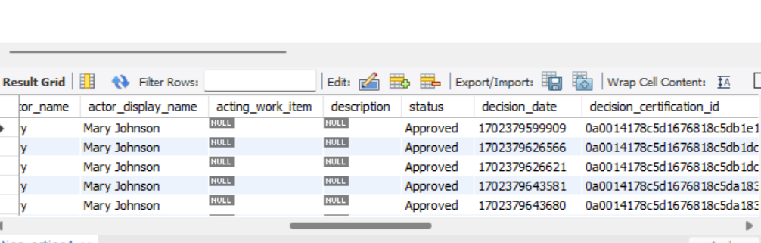

**>spt_certification_delegation**

----all reassigned certifications

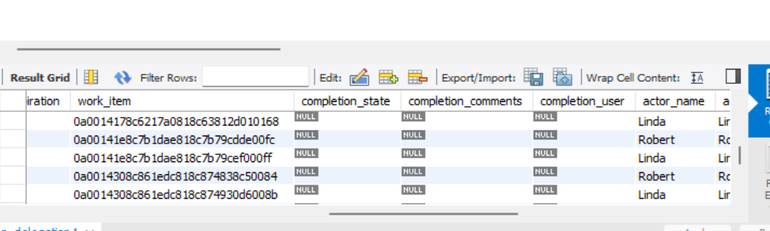

**>spt_cert_item_applications**

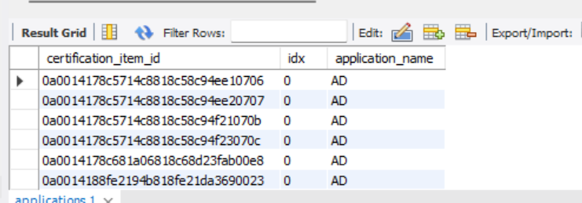

# **CORRELATION**

**>spt_correlation_config**

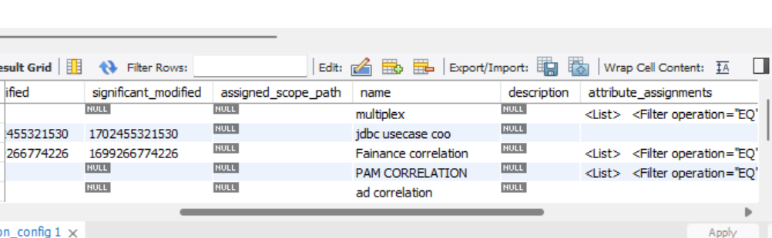

# **IDENTITIES**

**>spt_identity_entitlements**

-🡪all accesses

***assigned roles(business),detected roles(IT) and their ents)

**also individual ents (without roles)

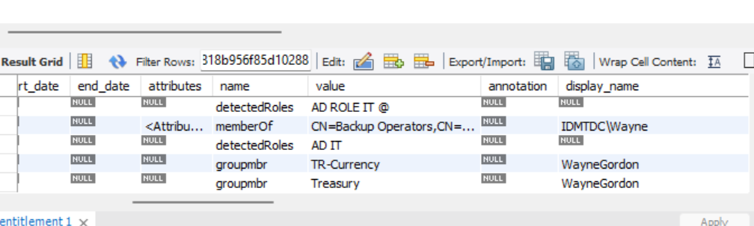

**>spt_identity_assignedRoles**

====only the assigned roles(Businness roles)

2 roles==2 rows

**>spt_identity_bundles**

========only the detected(IT Roles)

2 it roles===2 rows

**>spt_identity_external_attr**

--🡪multivalued attributes other than ents

**>spt_identity_request:**

**-🡪getting pending,completed,failure ,etc account and access request,identity request**

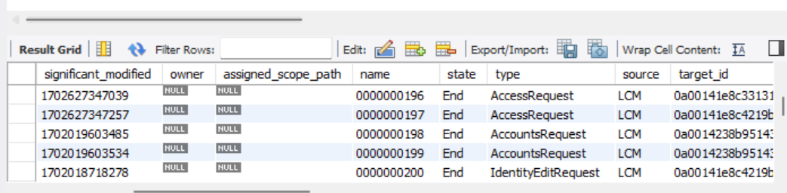

**>spt_identity_request_item**

**>spt_identity_trigger**

All lifecycle evnt triggers configured in iiq

# **GROUP**

**>spt_group_definition;**

Populations and Groups

**>spt_group_factory**

Only groups

**>spt_group_index**

Few pop and groups

# **ENTITLEMENT GROUP**

**>Spt_entitlementGroup**

-🡪only individual entitlements

1 row -🡪for application object

Eg:finance app -🡪3 ents-🡪only row

# **LINK**

**>spt_link**

All identities link

For eg james have 3 app acc-🡪3 diff rows

# **MANAGED ATTRIBUTE**

**>spt_managed_attribute**

Entitlements marked as managed in iiq

# **SCHEMA**

**>spt_schema_attributes**

All schema attributes in iiq

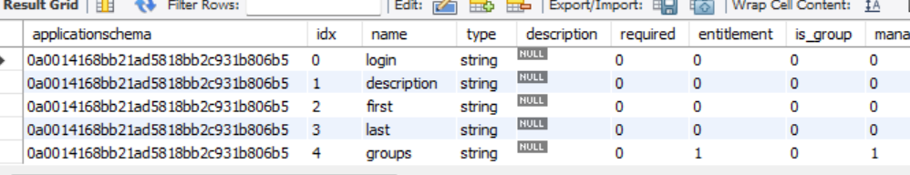

# **Application**

**>spt_application**

**>spt_application_schema**

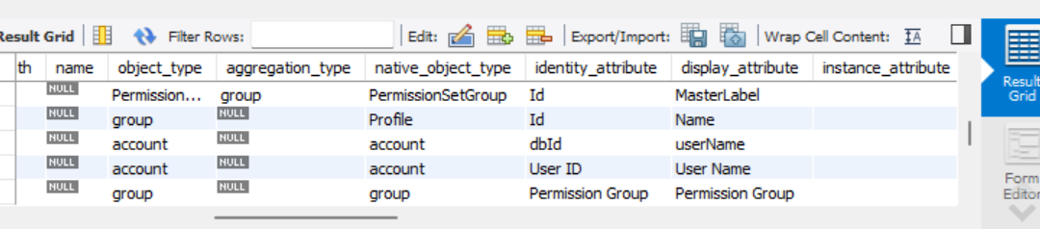

**>spt_application_scorecard;**

===application risk score info

**REQUEST**

**>spt_request**

when workflow is scheduled,

certification,workflows email templates requests

**>spt_request_returns**

**>spt_request_arguments**

OTHER:  
**>spt_object_config**

Lists ---what are the diff types of objects in iiq like identity,application

>spt_rules

>

## **>spt_bundle**

--------all Org, Business, IT roles configured in IIQ

